# A

**Synopsis On**

CRICKET LIVE SCORE

# Master of Computer Applications

### Submitted By:

**TARUN KUMAR- 2100290140141 RAKSHIT TYAGI - 2100290140111 SHASHANK TYAGI - 2100290140124**



### Submitted To:

**Dr. VIPIN KUMAR**

### Department of Computer Applications,

**KIET Group of Institutions, Delhi-NCR, Ghaziabad**

**September’2022**

**ABSTRACT**

There have been several tries at predicting sport games using data from the past, but humans are still superior at predicting sport outcomes. There are multiple commercial services which have sports analysis and prediction as their main business. They use “sophisticated software and statistical algorithms” to aid their data tracking, but at the core they still have experts analyzing the games manually. In the present article, we proposed the system to provide switch section for the live updated scores of crickets matches and football matches. We are used API of cricbuzz for cricket score. System shows the live score of all matches like T20, test match, IPL, one day international. System is implemented by using the JavaScript technology.

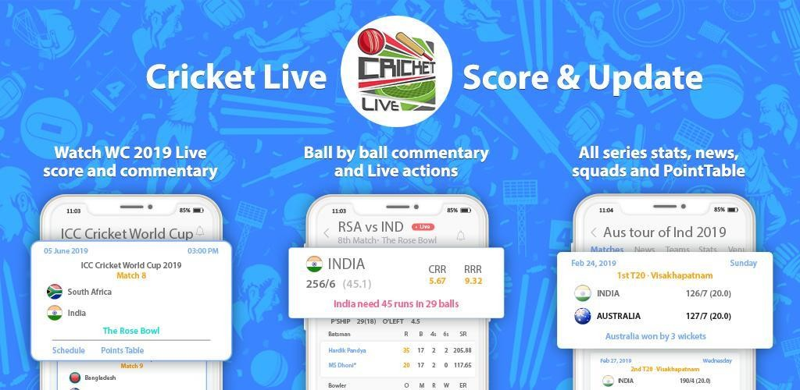

**TABLE OF CONTENTS**

#### Introduction

1. **Literature Review**

#### Project / Research Objective

1. **Research Methodology**

#### Project / Research Outcome

1. **Proposed Time Duration**

References

## Introduction

Cricket is one of the most popular sports in the world, with millions of fans tuning in to watch live matches and stay up-to-date with the latest scores. In today's fast-paced digital age, online cricket live score platforms have become an essential tool for cricket enthusiasts to stay informed and engaged with the latest cricket matches in real-time. Our project aims to provide a comprehensive and user-friendly cricket live score platform, allowing cricket fans to access live score updates, team and player statistics, and match highlights all in one place. With a range of features designed to cater to the needs of modern-day cricket enthusiasts, our platform aims to become the go-to destination for live cricket score updates

The reports can be viewed completely and the head of the management daily or weekly and monthly can review it.

* Developing and designing web page
* Admin login and dhasboard
* User login
* Score updation and player information
* Timetable
* Admin notification

#### 

**Literature Review**

* What is cricket live score ?

Staying up-to-date with the latest scores and match progress is super important for cricket betting enthusiasts, especially when it comes to high-octane tournaments like the Indian Premier League. But if you can't be there in person or tune in to live broadcasts, the next best thing is being able to keep track of the latest statistics.

Cricket has a global following of over 2.5 billion people, or approximately 33% of the entire world population. In India, the sport is considered no less than a religion with an unmatched following. And much like India, other South Asian countries like Bangladesh and Pakistan have a cricket-loving population.

* How does Cricket live score works ?

The project is about showing lives scores of the cricket match online. Many people don’t have television or cable connection at their place or if they are travelling then they may view the scores online. The system has an admin account where the scores are constantly updated by the admin. Users can login into the account to view the scores anytime. The system also provides a timetable of all the matches that would be going to be held for users to know in prior about the matches. Thus user can view cricket scores in real time.

**Project objective**

The project is about showing lives scores of the cricket match online. Many people don’t have television or cable connection at their place or if they are travelling then they may view the scores online. The system has an admin account where the scores are constantly updated by the admin. Users can login into the account to view the scores anytime. The system also provides a timetable of all the matches that would be going to be held for users to know in prior about the matches. Thus user can view cricket scores in real time.

**Features of the system:**

* **Admin login and dashboard:** Admin has a login from where he keeps updating the scores in real time. Admin can add different fields like match timetable, match updates, notifications etc.
* **User login:** User has to first register and login to view the scores. Users can see various timetables and updates in the system.
* **Score updation and player information:** The scores are constantly updated and posted and also provide a brief description about both the team players playing on ground at that time.
* **Timetables:** The system contains timetables of all the future matches to be held that also keeps on updating.
* **Admin notification:** Admin is provided an option where he can add notifications in the website for the users.
* **User enquiry and feedback form:** Users can ask for any query regarding matches to the admin by filling the enquiry form online. Also they can provide feedbacks from feedback form.

## Technologies / Software Requirements

We will be using various technologies such as:

* + HTML
  + CSS
  + BOOTSTRAP
  + JAVASCRIPT
  + NODE.js
  + MongoDB
  + API
  + VERCEL
  + VS CODE

## Hardware requirement / Hardware Used

* + Hardware- : Processor i3 or above
  + Clock speed- : 3.0 GHz
  + RAM size- : 4 GB [MINIMUM]
  + Hard Disk capacity- : 500 GB [MINIMUM]

## Research Methodology

#### Developing and designing web page

We will be designing the basic layout of the webpage with the help of HTML & CSS.

#### Admin login and dashboard

Admin has a login from where he keeps updating the scores in real time. Admin can add different fields like match timetable, match updates, notifications etc.

#### User login

User has to first register and login to view the scores. Users can see various timetables and updates in the system.

#### Score updation and player information

The scores are constantly updated and posted and also provide a brief description about both the team players playing on ground at that time.

#### Timetables

The system contains timetables of all the future matches to be held that also keeps on updating.

#### Admin notification

Admin is provided an option where he can add notifications in the website for the users. The admin can Add/Update the teams with the details and the user can view the overall information

**Project outcomes**

The project is about showing lives scores of the cricket match online. Many people don’t have television or cable connection at their place or if they are travelling then they may view the scores online.

Advantages:

* The user can view the scores from anywhere through internet.
* Users can keep themselves updated about matches.
* The system is flexible to use and is cost-effective.

Disadvantages:

* Internet connection is requisite for this system.
* One cannot view live match if wishes.

Applications:

* The system can be used where there is no television.

## Report/Output

After finishing all the modules and tasks, we should have a complete project. The user can view the scores from anywhere through internet. Users can keep themselves updated about matches.

## Conclusion

It is concluded that the Webpage works well and satisfy the end users. The application is tested very well and errors are properly debugged. The application is simultaneously accessed from more than one system.

Simultaneous login from more than one place is tested. This system is user friendly so everyone can use easily. The end user can easily understand how the whole system is implemented. The system is tested, implemented and the performance is found to be satisfactory. All necessary output is generated. Thus, the project is completed successfully. Further

enhancements can be made to the webpages, so that the webpages functions very attractive and useful manner than the present one. The speed of the transactions become more enough now.

## Gantt Chart in terms Of week

